Experiment 1: Vector and Matrix Operations for Deep Learning
Aim:
To develop a bookstore recommendation system using customer preferences, genre-book relationships, cosine similarity, and a dense neural network layer, and visualize the results using a heatmap.
Algorithm:
- Create a customer-genre preference matrix and a genre-book relationship matrix.
- Calculate cosine similarity to identify customers with similar preferences.
- Multiply the matrices to estimate customer preferences for different books.
- Apply a dense neural network layer using weights and bias.
- Display the recommendation scores.
- Visualize the customer preferences using a heatmap.
import numpy as np
import matplotlib.pyplot as plt
customers = np.array([
[5, 4, 0, 2, 1],
[4, 5, 1, 2, 0],
[0, 1, 5, 4, 3],
[1, 0, 4, 5, 4],
[3, 3, 2, 1, 4],
[5, 2, 1, 3, 2]
], dtype=float)
books = np.array([
[1, 0, 0, 1],
[0, 1, 1, 0],
[1, 1, 0, 0],
[0, 0, 1, 1],
[1, 0, 1, 0]
], dtype=float)
print("Customer Matrix:\n", customers)
print("\nBook Matrix:\n", books)
print("\nDot Product of first two customers:",
np.dot(customers[0], customers[1]))
scores = np.dot(customers, books)
print("\nCustomer-Book Score Matrix:\n", scores)
print("\nTranspose of Customer Matrix:\n", customers.T)
print("\nElement-wise Addition:\n", customers + 1)
print("\nElement-wise Multiplication:\n", customers * customers)
square_matrix = np.array([[4, 7], [2, 6]], dtype=float)
print("\nInverse of Matrix:\n", np.linalg.inv(square_matrix))
norms = np.linalg.norm(customers, axis=1)
similarity = customers @ customers.T / np.outer(norms, norms)
np.fill_diagonal(similarity, 0)
i, j = np.unravel_index(np.argmax(similarity), similarity.shape)
print("\nCosine Similarity Matrix:\n", np.round(similarity, 3))
print("Most Similar Customers:", i + 1, "and", j + 1)
print("Similarity:", round(similarity[i, j], 3))
W = np.array([[0.2, 0.4], [0.5, 0.1]])
x = np.array([5.0, 4.0])
b = np.array([1.0, 2.0])
y = W @ x + b
print("\nDense Layer Output:", y)
plt.imshow(scores, cmap="YlGnBu", aspect="auto")
plt.colorbar(label="Recommendation Score")
plt.xlabel("Book")
plt.ylabel("Customer")
plt.title("Customer-Book Score Heatmap")
plt.xticks(range(4), ["Book 1", "Book 2", "Book 3", "Book 4"])
plt.yticks(range(6), ["C1", "C2", "C3", "C4", "C5", "C6"])
plt.tight_layout()
plt.show()
OUTPUT
Customer Matrix:
[[5. 4. 0. 2. 1.]
[4. 5. 1. 2. 0.]
[0. 1. 5. 4. 3.]
[1. 0. 4. 5. 4.]
[3. 3. 2. 1. 4.]
[5. 2. 1. 3. 2.]]

Book Matrix:
[[1. 0. 0. 1.]
[0. 1. 1. 0.]
[1. 1. 0. 0.]
[0. 0. 1. 1.]
[1. 0. 1. 0.]]

Dot Product of first two customers: 44.0

Customer-Book Score Matrix:
[[6. 4. 7. 7.]
[5. 6. 7. 6.]
[8. 6. 8. 4.]
[9. 4. 9. 6.]
[9. 5. 8. 4.]
[8. 3. 7. 8.]]

Transpose of Customer Matrix:
[[5. 4. 0. 1. 3. 5.]
[4. 5. 1. 0. 3. 2.]
[0. 1. 5. 4. 2. 1.]
[2. 2. 4. 5. 1. 3.]
[1. 0. 3. 4. 4. 2.]]
Element-wise Addition:
[[6. 5. 1. 3. 2.]
[5. 6. 2. 3. 1.]
[1. 2. 6. 5. 4.]
[2. 1. 5. 6. 5.]
[4. 4. 3. 2. 5.]
[6. 3. 2. 4. 3.]]

Element-wise Multiplication:
[[25. 16. 0. 4. 1.]
[16. 25. 1. 4. 0.]
[ 0. 1. 25. 16. 9.]
[ 1. 0. 16. 25. 16.]
[ 9. 9. 4. 1. 16.]
[25. 4. 1. 9. 4.]]

Inverse of Matrix:
[[ 0.6 -0.7]
[-0.2 0.4]]

Cosine Similarity Matrix:
[[0. 0.957 0.31 0.368 0.779 0.922]
[0.957 0. 0.372 0.348 0.732 0.832]
[0.31 0.372 0. 0.956 0.65 0.534]
[0.368 0.348 0.956 0. 0.673 0.641]
[0.779 0.732 0.65 0.673 0. 0.83 ]
[0.922 0.832 0.534 0.641 0.83 0. ]]
Most Similar Customers: 1 and 2
Similarity: 0.957
Dense Layer Output: [3.6 4.9]
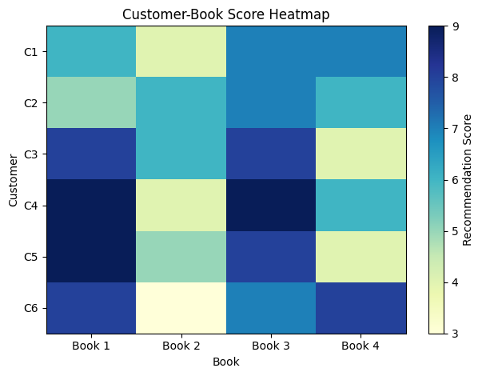
Result:
The bookstore recommendation system was implemented successfully, and book recommendations were generated based on customer preferences and similarity scores.

2. Covariance, Eigen Values, Eigen Vectors
Aim:
To calculate the covariance matrix, eigenvalues, and eigenvectors of a dataset and understand how they represent relationships and directions of variation in the data.
Algorithm:
- Create or load a numerical dataset.
- Calculate the mean of each feature.
- Center the dataset by subtracting the feature means.
- Calculate the covariance matrix.
- Find the eigenvalues and eigenvectors of the covariance matrix.
- Sort the eigenvalues in descending order and arrange their corresponding eigenvectors.
- Interpret the eigenvalues and eigenvectors to identify the directions of maximum variation.
Code:
import numpy as np
import pandas as pd
import matplotlib.pyplot as plt
np.random.seed(10)
n = 200
haemoglobin = np.random.normal(13, 1.5, n)
rbc = 4.5 + 0.25 * haemoglobin + np.random.normal(0, 0.3, n)
glucose = np.random.normal(110, 15, n)
cholesterol = 180 + 0.5 * glucose + np.random.normal(0, 12, n)
bmi = np.random.normal(25, 4, n)
df = pd.DataFrame({
"Haemoglobin": haemoglobin,
"RBC": rbc,
"Glucose": glucose,
"Cholesterol": cholesterol,
"BMI": bmi
})
print("First Five Patient Records:\n", df.head().round(2))
X = (df - df.mean()) / df.std(ddof=0)
cov = X.cov()
corr = X.corr()
print("\nCovariance Matrix:\n", cov.round(3))
print("\nCorrelation Matrix:\n", corr.round(3))
values, vectors = np.linalg.eigh(corr)
order = np.argsort(values)[::-1]
values = values[order]
vectors = vectors[:, order]
variance = values / values.sum() * 100
print("\nEigenvalues:\n", values.round(4))
print("\nExplained Variance (%):\n", variance.round(2))
print("\nEigenvectors:\n", vectors.round(3))
fig, ax = plt.subplots(1, 2, figsize=(12, 5))
im1 = ax[0].imshow(cov, cmap="coolwarm")
ax[0].set_title("Covariance Matrix")
ax[0].set_xticks(range(5), df.columns, rotation=45)
ax[0].set_yticks(range(5), df.columns)
fig.colorbar(im1, ax=ax[0])
im2 = ax[1].imshow(corr, cmap="coolwarm", vmin=-1, vmax=1)
ax[1].set_title("Correlation Matrix")
ax[1].set_xticks(range(5), df.columns, rotation=45)
ax[1].set_yticks(range(5), df.columns)
fig.colorbar(im2, ax=ax[1])
plt.tight_layout()
plt.show()
projected = X.to_numpy() @ vectors[:, :2]
plt.scatter(projected[:, 0], projected[:, 1], alpha=0.6)
plt.xlabel("Principal Component 1")
plt.ylabel("Principal Component 2")
plt.title("Patient Data Projected onto First Two Components")
plt.show()
OUTPUT
First Five Patient Records:
Haemoglobin RBC Glucose Cholesterol BMI
0 15.00 8.29 116.94 245.32 25.08
1 14.07 8.38 91.70 219.70 25.63
2 10.68 6.86 112.89 239.75 29.15
3 12.99 7.79 116.53 233.59 25.18
4 13.93 7.64 85.48 230.52 29.43

Covariance Matrix:
Haemoglobin RBC Glucose Cholesterol BMI
Haemoglobin 1.005 0.793 -0.042 -0.056 -0.007
RBC 0.793 1.005 0.058 -0.049 -0.046
Glucose -0.042 0.058 1.005 0.525 -0.046
Cholesterol -0.056 -0.049 0.525 1.005 -0.022
BMI -0.007 -0.046 -0.046 -0.022 1.005

Correlation Matrix:
Haemoglobin RBC Glucose Cholesterol BMI
Haemoglobin 1.000 0.789 -0.042 -0.056 -0.007
RBC 0.789 1.000 0.058 -0.049 -0.046
Glucose -0.042 0.058 1.000 0.522 -0.046
Cholesterol -0.056 -0.049 0.522 1.000 -0.022
BMI -0.007 -0.046 -0.046 -0.022 1.000
Eigenvalues:
[1.8005 1.523 0.9944 0.4822 0.1999]
Explained Variance (%):
[36.01 30.46 19.89 9.64 4. ]
Eigenvectors:
[[-0.7 0.073 -0.06 -0.147 0.693]
[-0.696 0.133 -0.018 0.083 -0.701]
[ 0.074 0.703 -0.05 0.69 0.143]
[ 0.139 0.686 -0.09 -0.702 -0.089]
[ 0.038 -0.104 -0.993 0.036 -0.028]]
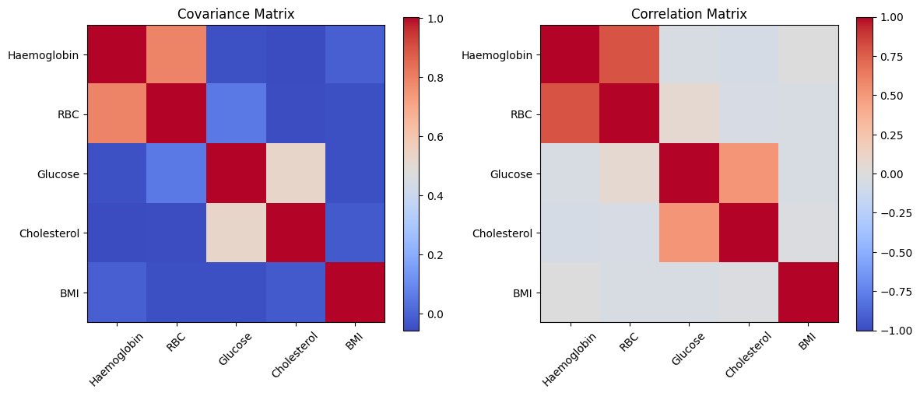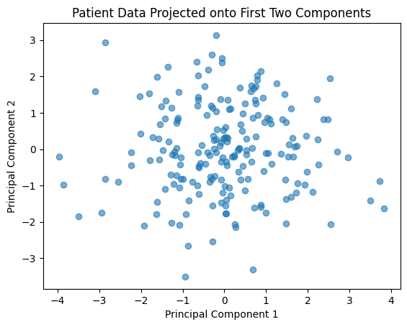
Experiment 3: Probability Distributions and Bayes’ Theorem
Aim:
To study probability distributions and apply Bayes’ theorem to calculate conditional probabilities and update predictions using new evidence.
Algorithm:
- Define the given events and their probabilities.
- Calculate the joint and conditional probabilities.
- Apply Bayes’ theorem to find the required probability.
- Compare the calculated probabilities and interpret the results.
Code:
#3)
import numpy as np
import matplotlib.pyplot as plt
from scipy.stats import bernoulli, binom, poisson, uniform, norm
np.random.seed(42)
n = 100000
distributions = {
"Bernoulli": bernoulli(0.3),
"Binomial": binom(10, 0.3),
"Poisson": poisson(4),
"Uniform": uniform(0, 1),
"Gaussian": norm(0, 1)}
fig, axes = plt.subplots(2, 3, figsize=(13, 7))
for ax, (name, dist) in zip(axes.flat, distributions.items()):
samples = dist.rvs(size=2000)
ax.hist(samples, bins=30, density=True, alpha=0.6)
x = np.arange(0, 11) if name == "Binomial" else np.linspace(
min(samples), max(samples), 200)
if name in ["Bernoulli", "Binomial", "Poisson"]:
x = np.arange(0, 11)
ax.plot(x, dist.pmf(x), "ro")
else:
ax.plot(x, dist.pdf(x), "r-")
ax.set_title(name)
axes.flat[-1].axis("off")
plt.tight_layout()
plt.show()
prevalence = 0.01
sensitivity = 0.95
specificity = 0.90
true_positive = sensitivity * prevalence
false_positive = (1 - specificity) * (1 - prevalence)
posterior = true_positive / (true_positive + false_positive)
print("Bayes' Theorem Result")
print("P(Disease | Positive) =", round(posterior, 4))
print("Percentage =", round(posterior * 100, 2), "%")
disease = np.random.rand(n) < prevalence
positive = np.where(
disease,
np.random.rand(n) < sensitivity,
np.random.rand(n) < (1 - specificity))
empirical = disease[positive].mean()
print("\nSimulation Results")
print("Patients:", n)
print("Positive tests:", positive.sum())
print("Empirical probability:", round(empirical, 4))
print("Empirical percentage:", round(empirical * 100, 2), "%")
prev = np.linspace(0.001, 0.20, 200)
post = (sensitivity * prev) / (
sensitivity * prev + (1 - specificity) * (1 - prev))
plt.plot(prev * 100, post * 100)
plt.xlabel("Disease Prevalence (%)")
plt.ylabel("P(Disease | Positive) (%)")
plt.title("Posterior Probability vs Prevalence")
plt.grid()
plt.show()
Output:
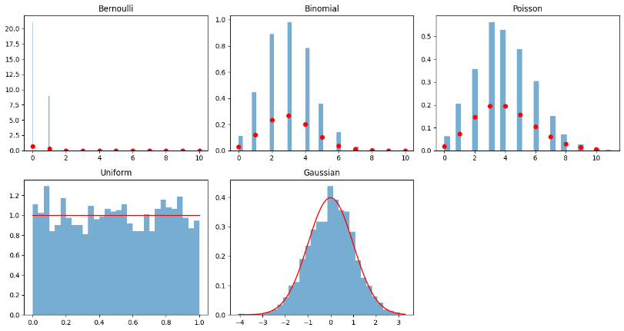
Bayes' Theorem Result
P(Disease | Positive) = 0.0876
Percentage = 8.76 %
Simulation Results
Patients: 100000
Positive tests: 10887
Empirical probability: 0.0876
Empirical percentage: 8.76 %
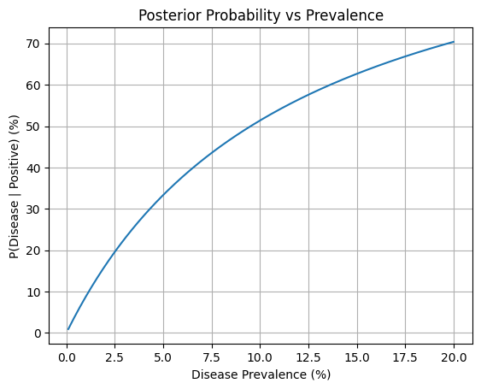
Result:
Probability distributions and Bayes’ theorem were implemented successfully, and the required conditional probabilities were calculated.
Experiment 4: Entropy, Cross-Entropy and KL Divergence
Aim:
To calculate entropy, cross-entropy, and Kullback–Leibler (KL) divergence and understand how they measure uncertainty and differences between probability distributions.
Algorithm:
- Define the actual and predicted probability distributions.
- Calculate entropy using the given probabilities.
- Calculate cross-entropy between the actual and predicted distributions.
- Calculate KL divergence and compare the distributions.
- Interpret the calculated values.
Code:
#4)

import numpy as np
import matplotlib.pyplot as plt
from scipy.special import rel_entr
true = np.array([0.5, 0.3, 0.2])
model1 = np.array([0.6, 0.25, 0.15])
model2 = np.array([0.2, 0.3, 0.5])
def entropy(p):
return -np.sum(p * np.log2(p))
def cross_entropy(p, q):
return -np.sum(p * np.log2(q))
def kl_divergence(p, q):
return np.sum(rel_entr(p, q)) / np.log(2)
H = entropy(true)
for name, model in [("Model 1", model1), ("Model 2", model2)]:
CE = cross_entropy(true, model)
KL = kl_divergence(true, model)
print("\n", name)
print("Cross-Entropy:", round(CE, 4))
print("KL Divergence:", round(KL, 4))
print("Entropy + KL:", round(H + KL, 4))
print("\nTrue Entropy:", round(H, 4))
print("KL(true || model1):", round(kl_divergence(true, model1), 4))
print("KL(model1 || true):", round(kl_divergence(model1, true), 4))
p = np.linspace(0.001, 0.999, 300)
y = 1
loss = -(y * np.log(p) + (1 - y) * np.log(1 - p))
plt.plot(p, loss)
plt.xlabel("Predicted Probability of Positive Class")
plt.ylabel("Binary Cross-Entropy Loss")
plt.title("Binary Cross-Entropy Loss (Actual Class = 1)")
plt.grid()
plt.show()
Output:
Model 1
Cross-Entropy: 1.5159
KL Divergence: 0.0304
Entropy + KL: 1.5159

Model 2
Cross-Entropy: 1.8821
KL Divergence: 0.3966
Entropy + KL: 1.8821

True Entropy: 1.4855
KL(true || model1): 0.0304
KL(model1 || true): 0.0298
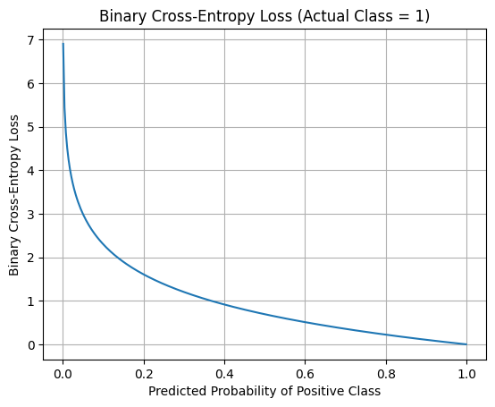
Result:
Entropy, cross-entropy, and KL divergence were calculated successfully to measure uncertainty and differences between probability distributions.
Experiment 5: Bias–Variance Trade-off and Overfitting
Aim:
To analyse bias, variance, underfitting, and overfitting by comparing model errors at different levels of model complexity.
Algorithm:
- Generate or load a sample dataset.
- Train models with different levels of complexity.
- Calculate training and validation errors.
- Plot the errors against model complexity.
- Identify underfitting, overfitting, and the suitable model.
Code:
#5)

import numpy as np
import matplotlib.pyplot as plt
from sklearn.preprocessing import PolynomialFeatures
from sklearn.linear_model import LinearRegression
from sklearn.pipeline import make_pipeline
from sklearn.model_selection import train_test_split
from sklearn.metrics import mean_squared_error
np.random.seed(42)
X = np.sort(np.random.uniform(0, 10, 150)).reshape(-1, 1)
y = 2 * X[:, 0] + 0.5 * X[:, 0] ** 2 + np.sin(2 * X[:, 0])
y += np.random.normal(0, 3, 150)
X_train, X_val, y_train, y_val = train_test_split(
X, y, test_size=0.25, random_state=42)
degrees = [1, 3, 9, 15]
train_errors = []
val_errors = []
grid = np.linspace(0, 10, 300).reshape(-1, 1)
plt.figure(figsize=(10, 6))
plt.scatter(X_train, y_train, label="Training Data", alpha=0.6)
plt.scatter(X_val, y_val, label="Validation Data", alpha=0.6)
for degree in degrees:
model = make_pipeline(
PolynomialFeatures(degree),
LinearRegression())
model.fit(X_train, y_train)
train_pred = model.predict(X_train)
val_pred = model.predict(X_val)
train_errors.append(mean_squared_error(y_train, train_pred))
val_errors.append(mean_squared_error(y_val, val_pred))
plt.plot(grid, model.predict(grid), label=f"Degree {degree}")
print("\nDegree:", degree)
print("Training MSE:", round(train_errors[-1], 3))
print("Validation MSE:", round(val_errors[-1], 3))
plt.xlabel("House Area")
plt.ylabel("House Price")
plt.title("Polynomial Regression: Underfitting and Overfitting")
plt.legend()
plt.grid()
plt.show()
plt.plot(degrees, train_errors, "o-", label="Training Error")
plt.plot(degrees, val_errors, "s-", label="Validation Error")
plt.xlabel("Polynomial Degree")
plt.ylabel("Mean Squared Error")
plt.title("Error vs Model Complexity")
plt.legend()
plt.grid()
plt.show()
best_degree = degrees[np.argmin(val_errors)]
print("\nBest Degree:", best_degree)
predictions = []
for seed in range(30):
rng = np.random.default_rng(seed)
indices = rng.integers(0, len(X_train), len(X_train))
model = make_pipeline(
PolynomialFeatures(best_degree),
LinearRegression())
model.fit(X_train[indices], y_train[indices])
predictions.append(model.predict(grid))
predictions = np.array(predictions)
mean_prediction = predictions.mean(axis=0)
bias_squared = np.mean((mean_prediction - (
2 * grid[:, 0] + 0.5 * grid[:, 0] ** 2
+ np.sin(2 * grid[:, 0])
)) ** 2)
variance = np.mean(np.var(predictions, axis=0))
print("Estimated Bias^2:", round(bias_squared, 3))
print("Estimated Variance:", round(variance, 3))
Output:
Degree: 1
Training MSE: 23.302
Validation MSE: 18.326

Degree: 3
Training MSE: 10.127
Validation MSE: 7.636

Degree: 9
Training MSE: 9.198
Validation MSE: 8.824

Degree: 15
Training MSE: 9.174
Validation MSE: 8.416
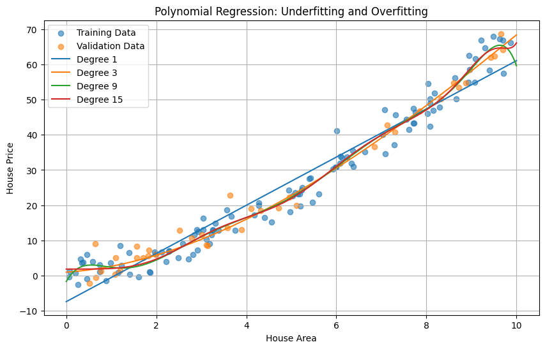
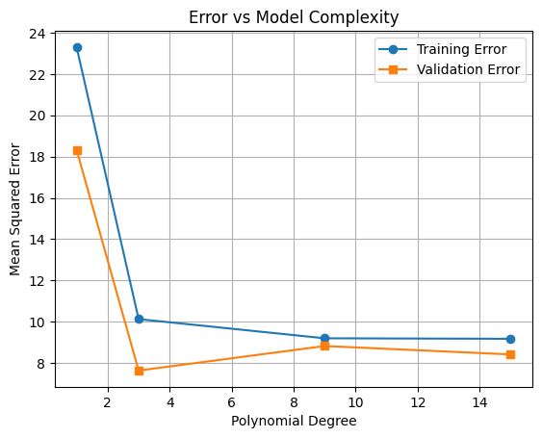

Result:
The bias–variance trade-off was analysed, and the relationship between model complexity, underfitting, and overfitting was identified.
Experiment 6: Gradient Descent, SGD, Momentum and Adam
Aim:
To implement and compare Gradient Descent, Stochastic Gradient Descent (SGD), Momentum, and Adam for minimizing a loss function.
Algorithm:
- Define the model, parameters, and loss function.
- Initialize the model parameters.
- Calculate the gradients of the loss function.
- Update parameters using Gradient Descent, SGD, Momentum, and Adam.
- Compare the loss values and convergence of each optimizer.
Code:
#6)

import numpy as np
import matplotlib.pyplot as plt
import tensorflow as tf
np.random.seed(42)
tf.random.set_seed(42)
def loss_fn(w):
return 0.5 * (w[0] ** 2 + 10 * w[1] ** 2)
def gradient(w):
return np.array([w[0], 10 * w[1]])
initial = np.array([4.0, 4.0])
optimizers = ["GD", "SGD", "Momentum"]
paths = {}
for name in optimizers:
w = initial.copy()
velocity = np.zeros(2)
path = [w.copy()]
for step in range(100):
grad = gradient(w)
if name == "GD":
w -= 0.05 * grad
elif name == "SGD":
noisy_grad = grad + np.random.normal(0, 0.2, 2)
w -= 0.01 * noisy_grad
else:
velocity = 0.9 * velocity + grad
w -= 0.05 * velocity
path.append(w.copy())
paths[name] = np.array(path)
x = np.linspace(-4, 4, 100)
y = np.linspace(-4, 4, 100)
X, Y = np.meshgrid(x, y)
Z = 0.5 * (X ** 2 + 10 * Y ** 2)
plt.contour(X, Y, Z, levels=30)
for name, path in paths.items():
plt.plot(path[:, 0], path[:, 1], marker=".", label=name)
plt.xlabel("w1")
plt.ylabel("w2")
plt.title("Optimiser Paths on Loss Contours")
plt.legend()
plt.show()
X_data = np.random.rand(500, 4).astype("float32")
y_data = (
5 * X_data[:, 0] +
3 * X_data[:, 1] +
2 * X_data[:, 2] +
X_data[:, 3]
).astype("float32")
X_train, X_val = X_data[:400], X_data[400:]
y_train, y_val = y_data[:400], y_data[400:]
optimizers = {
"SGD": tf.keras.optimizers.SGD(learning_rate=0.01),
"Momentum": tf.keras.optimizers.SGD(
learning_rate=0.01,
momentum=0.9
),
"Adam": tf.keras.optimizers.Adam(learning_rate=0.01)
}
histories = {}
for name, optimizer in optimizers.items():
model = tf.keras.Sequential([
tf.keras.layers.Input(shape=(4,)),
tf.keras.layers.Dense(16, activation="relu"),
tf.keras.layers.Dense(1)
])
model.compile(optimizer=optimizer, loss="mse")
history = model.fit(
X_train, y_train,
validation_data=(X_val, y_val),
epochs=50,
batch_size=32,
verbose=0)
histories[name] = history.history["loss"]
print(name)
print("Initial Loss:", round(history.history["loss"][0], 4))
print("Final Loss:", round(history.history["loss"][-1], 4))
print("Final Validation Loss:",
round(history.history["val_loss"][-1], 4))
for name, losses in histories.items():
plt.plot(losses, label=name)
plt.xlabel("Epoch")
plt.ylabel("Training MSE Loss")
plt.title("Optimiser Comparison")
plt.legend()
plt.grid()
plt.show()
Output:
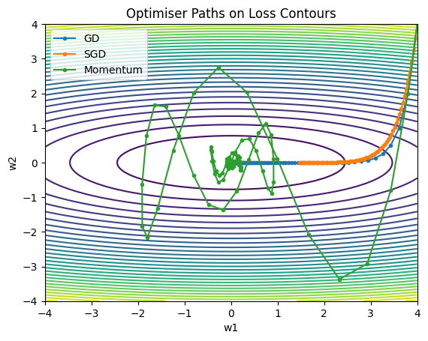
SGD
Initial Loss: 15.6359
Final Loss: 0.0018
Final Validation Loss: 0.0012
Momentum
Initial Loss: 11.6571
Final Loss: 0.003
Final Validation Loss: 0.0008
Adam
Initial Loss: 27.2465
Final Loss: 0.0004
Final Validation Loss: 0.0004
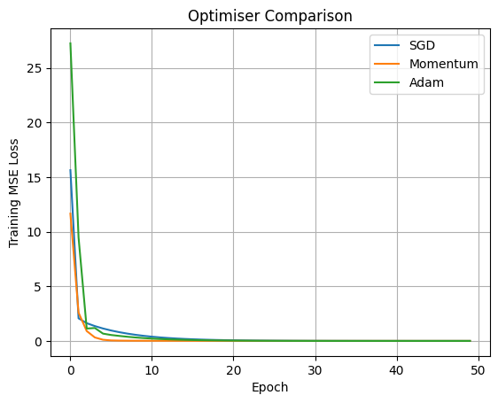
Result:
The four optimization methods were implemented and compared based on loss reduction and convergence behaviour.
Experiment 7: Perceptron and Forward Propagation
Aim:
To implement a perceptron for binary classification, study forward propagation, and understand the limitations of a single-layer perceptron using linearly separable data and the XOR problem.

Algorithm:
- Create a dataset with input features and target labels.
- Initialize weights and bias.
- Calculate the weighted sum of inputs.
- Apply an activation function to predict the output.
- Update weights and bias based on prediction errors.
- Test the model using linearly separable data and XOR inputs.
Code:
#7) Perceptron and Forward Propagation

import numpy as np
import matplotlib.pyplot as plt
np.random.seed(42)
def step(z):
return (z >= 0).astype(int)
def sigmoid(z):
return 1 / (1 + np.exp(-np.clip(z, -500, 500)))
def relu(z):
return np.maximum(0, z)
# Task 1: Weighted sum, bias and step activation
x = np.array([0.7, 0.4])
w = np.array([0.8, -0.5])
b = 0.1
z = np.dot(w, x) + b
print("Weighted Sum:", round(z, 3))
print("Step Output:", step(np.array(z)).item())
print("Sigmoid Output:", round(sigmoid(z).item(), 4))
print("ReLU Output:", round(relu(z).item(), 3))
# Task 2: Generate 100 illustrative loan applications
X = np.random.rand(100, 2)
y = ((X[:, 0] >= 0.5) & (X[:, 1] >= 0.4)).astype(int)
weights = np.zeros(2)
bias = 0.0
lr = 0.1
epochs = 20
updates = []
for epoch in range(epochs):
mistakes = 0
for xi, target in zip(X, y):
prediction = step(np.array(np.dot(weights, xi) + bias)).item()
error = target - prediction
weights += lr * error * xi
bias += lr * error
mistakes += int(error != 0)
updates.append(mistakes)
print("Epoch", epoch + 1, "Errors:", mistakes,
"Weights:", np.round(weights, 3),
"Bias:", round(bias, 3))
# Task 3: Decision boundary
plt.figure(figsize=(7, 5))
plt.scatter(X[:, 0], X[:, 1], c=y, cmap="coolwarm")
xx = np.linspace(0, 1, 100)
if abs(weights[1]) > 1e-10:
yy = -(weights[0] * xx + bias) / weights[1]
plt.plot(xx, yy, "k--", label="Decision boundary")
plt.xlabel("Credit Score (normalised)")
plt.ylabel("Income-to-Debt Score")
plt.title("Perceptron Loan Screening")
plt.ylim(0, 1)
plt.legend()
plt.show()
plt.plot(range(1, epochs + 1), updates, marker="o")
plt.xlabel("Epoch")
plt.ylabel("Misclassified Applications")
plt.title("Perceptron Learning")
plt.grid()
plt.show()
# Task 4: XOR
XOR_X = np.array([[0, 0], [0, 1], [1, 0], [1, 1]])
XOR_y = np.array([0, 1, 1, 0])
w_xor = np.zeros(2)
b_xor = 0.0
for epoch in range(20):
for xi, target in zip(XOR_X, XOR_y):
prediction = step(np.array(np.dot(w_xor, xi) + b_xor)).item()
error = target - prediction
w_xor += 0.1 * error * xi
b_xor += 0.1 * error
predictions = step(XOR_X @ w_xor + b_xor)
print("\nXOR Actual:", XOR_y)
print("XOR Predicted:", predictions)
print("XOR Correct:", np.sum(predictions == XOR_y), "out of 4")
print("XOR converged:", np.array_equal(predictions, XOR_y))
# Task 5: Activation comparison
z_values = np.linspace(-5, 5, 200)
plt.plot(z_values, (z_values >= 0).astype(int), label="Step")
plt.plot(z_values, sigmoid(z_values), label="Sigmoid")
plt.plot(z_values, relu(z_values), label="ReLU")
plt.xlabel("Input z")
plt.ylabel("Activation Output")
plt.title("Activation Function Comparison")
plt.legend()
plt.grid()
plt.show()
Output:
Weighted Sum: 0.46
Step Output: 1
Sigmoid Output: 0.613
ReLU Output: 0.46
Epoch 1 Errors: 33 Weights: [0.253 0.199] Bias: -0.3
Epoch 2 Errors: 23 Weights: [0.384 0.207] Bias: -0.4
Epoch 3 Errors: 14 Weights: [0.389 0.251] Bias: -0.4
Epoch 4 Errors: 14 Weights: [0.372 0.363] Bias: -0.4
Epoch 5 Errors: 21 Weights: [0.401 0.36 ] Bias: -0.5
Epoch 6 Errors: 12 Weights: [0.386 0.374] Bias: -0.5
Epoch 7 Errors: 14 Weights: [0.404 0.345] Bias: -0.5
Epoch 8 Errors: 12 Weights: [0.389 0.359] Bias: -0.5
Epoch 9 Errors: 12 Weights: [0.387 0.363] Bias: -0.5
Epoch 10 Errors: 12 Weights: [0.372 0.377] Bias: -0.5
Epoch 11 Errors: 12 Weights: [0.366 0.391] Bias: -0.5
Epoch 12 Errors: 14 Weights: [0.387 0.37 ] Bias: -0.5
Epoch 13 Errors: 12 Weights: [0.372 0.384] Bias: -0.5
Epoch 14 Errors: 14 Weights: [0.389 0.355] Bias: -0.5
Epoch 15 Errors: 12 Weights: [0.387 0.358] Bias: -0.5
Epoch 16 Errors: 12 Weights: [0.385 0.362] Bias: -0.5
Epoch 17 Errors: 12 Weights: [0.384 0.365] Bias: -0.5
Epoch 18 Errors: 12 Weights: [0.382 0.369] Bias: -0.5
Epoch 19 Errors: 12 Weights: [0.367 0.383] Bias: -0.5
Epoch 20 Errors: 14 Weights: [0.387 0.362] Bias: -0.5
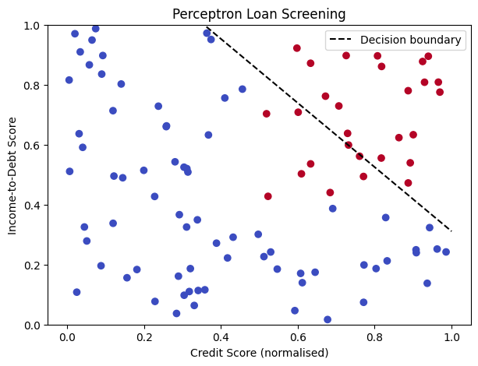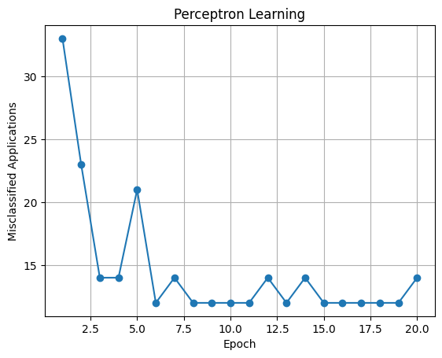
XOR Actual: [0 1 1 0]
XOR Predicted: [1 1 0 0]
XOR Correct: 2 out of 4
XOR converged: False
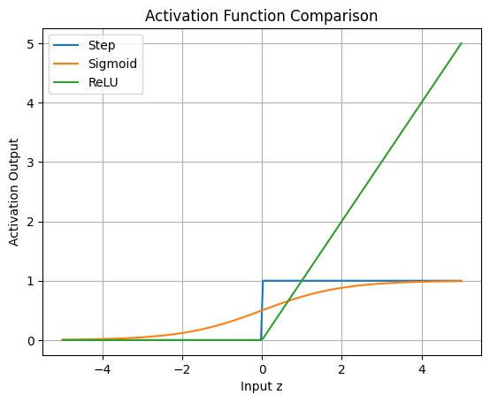
Result:
The perceptron was implemented successfully, and its ability to classify linearly separable data and its limitation in solving XOR were demonstrated.
Experiment 8: Two-Layer Neural Network Using Backpropagation
Aim:
To implement a two-layer neural network using forward propagation and backpropagation to solve the XOR classification problem and study error reduction during training.
Algorithm:
- Prepare the input and target data for XOR.
- Initialize weights and biases for the hidden and output layers.
- Perform forward propagation to calculate the predicted output.
- Calculate the loss between predicted and actual outputs.
- Use backpropagation to calculate gradients.
- Update weights and biases repeatedly.
- Check the final predictions and plot the training loss.
Code:
#8) Two-Layer Neural Network with Backpropagation

import numpy as np
import matplotlib.pyplot as plt
np.random.seed(42)
def sigmoid(z):
z = np.clip(z, -500, 500)
return 1 / (1 + np.exp(-z))
def forward(X, W1, b1, W2, b2):
Z1 = X @ W1 + b1
A1 = sigmoid(Z1)
Z2 = A1 @ W2 + b2
A2 = sigmoid(Z2)
return Z1, A1, Z2, A2
def calculate_loss(A2, y):
return -np.mean(
y * np.log(A2 + 1e-8) +
(1 - y) * np.log(1 - A2 + 1e-8)
)
def backpropagation(X, y, W1, b1, W2, b2):
n = len(X)
Z1, A1, Z2, A2 = forward(X, W1, b1, W2, b2)
dZ2 = (A2 - y) / n
dW2 = A1.T @ dZ2
db2 = np.sum(dZ2, axis=0, keepdims=True)
dZ1 = (dZ2 @ W2.T) * A1 * (1 - A1)
dW1 = X.T @ dZ1
db1 = np.sum(dZ1, axis=0, keepdims=True)
return dW1, db1, dW2, db2, A2
# Input: XOR dataset
X = np.array([
[0, 0],
[0, 1],
[1, 0],
[1, 1]
], dtype=float)
y = np.array([[0], [1], [1], [0]], dtype=float)
# Initialise weights and biases
W1 = np.random.randn(2, 8) * 0.5
b1 = np.zeros((1, 8))
W2 = np.random.randn(8, 1) * 0.5
b2 = np.zeros((1, 1))
print("INPUT DATA:")
print(X)
print("EXPECTED OUTPUT:")
print(y.ravel())
# Numerical gradient check before training
dW1, db1, dW2, db2, A2 = backpropagation(
X, y, W1, b1, W2, b2
)
epsilon = 1e-5
original = W1[0, 0]
W1[0, 0] = original + epsilon
_, _, _, A_plus = forward(X, W1, b1, W2, b2)
loss_plus = calculate_loss(A_plus, y)
W1[0, 0] = original - epsilon
_, _, _, A_minus = forward(X, W1, b1, W2, b2)
loss_minus = calculate_loss(A_minus, y)
W1[0, 0] = original
numerical_gradient = (loss_plus - loss_minus) / (2 * epsilon)
analytic_gradient = dW1[0, 0]
print("\nGRADIENT CHECK:")
print("Numerical gradient:", round(float(numerical_gradient), 6))
print("Analytical gradient:", round(float(analytic_gradient), 6))
print("Gradient check passed:",
np.isclose(numerical_gradient, analytic_gradient,
rtol=1e-3, atol=1e-5))
# Train using gradient descent and backpropagation
epochs = 10000
learning_rate = 1.0
losses = []
for epoch in range(epochs):
dW1, db1, dW2, db2, A2 = backpropagation(
X, y, W1, b1, W2, b2
)
W1 -= learning_rate * dW1
b1 -= learning_rate * db1
W2 -= learning_rate * dW2
b2 -= learning_rate * db2
if epoch % 100 == 0:
_, _, _, A2 = forward(X, W1, b1, W2, b2)
losses.append(calculate_loss(A2, y))
# Final predictions
_, _, _, probabilities = forward(X, W1, b1, W2, b2)
predictions = (probabilities >= 0.5).astype(int)
print("\nTRAINING RESULTS:")
print("Epochs:", epochs)
print("Final loss:", round(float(calculate_loss(probabilities, y)), 6))
print("Predicted probabilities:")
print(np.round(probabilities.ravel(), 4))
print("Predicted classes:", predictions.ravel())
print("Actual classes:", y.ravel())
print("Accuracy:",
round(float(np.mean(predictions == y) * 100), 2), "%")
# Plot training loss
plt.figure(figsize=(7, 4))
plt.plot(np.arange(len(losses)) * 100, losses)
plt.xlabel("Epoch")
plt.ylabel("Binary cross-entropy loss")
plt.title(" Training Loss")
plt.grid(True)
plt.show()
# Plot nonlinear decision boundary
xx, yy = np.meshgrid(
np.linspace(-0.2, 1.2, 150),
np.linspace(-0.2, 1.2, 150))
grid = np.c_[xx.ravel(), yy.ravel()]
_, _, _, grid_probs = forward(grid, W1, b1, W2, b2)
Z = (grid_probs >= 0.5).astype(int).reshape(xx.shape)
plt.figure(figsize=(6, 5))
plt.contourf(xx, yy, Z, alpha=0.3, levels=[-0.5, 0.5, 1.5])
plt.scatter(X[:, 0], X[:, 1], c=y.ravel(),
edgecolors="black", s=100)
plt.xlabel("Input X1")
plt.ylabel("Input X2")
plt.title("XOR Nonlinear Decision Boundary")
plt.grid(True)
plt.show()
Output:
INPUT DATA:
[[0. 0.]
[0. 1.]
[1. 0.]
[1. 1.]]
EXPECTED OUTPUT:
[0. 1. 1. 0.]
GRADIENT CHECK:
Numerical gradient: 0.013816
Analytical gradient: 0.013816
Gradient check passed: True
TRAINING RESULTS:
Epochs: 10000
Final loss: 0.00067
Predicted probabilities:
[5.000e-04 9.994e-01 9.992e-01 8.000e-04]
Predicted classes: [0 1 1 0]
Actual classes: [0. 1. 1. 0.]
Accuracy: 100.0 %
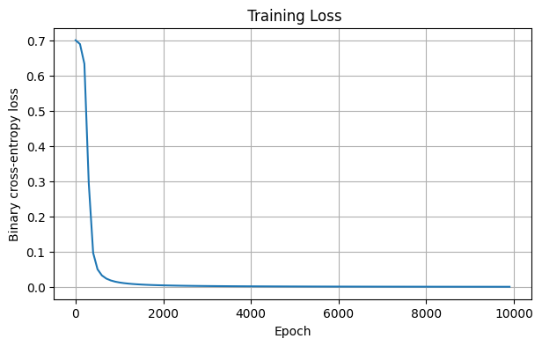
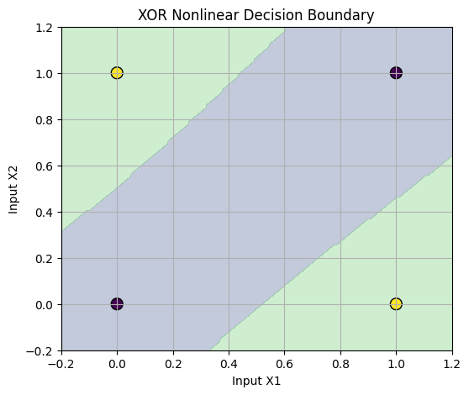
Result:
The two-layer neural network was trained successfully using backpropagation and learned the XOR input-output relationships.
Experiment 9: Multilayer Perceptron (MLP)
Aim:
To build and train a Multilayer Perceptron for classification and analyse the effect of hidden layers, activation functions, and model performance.
Algorithm:
- Load or generate a classification dataset.
- Split the dataset into training and testing sets.
- Create an MLP with one or more hidden layers.
- Train the model using a suitable optimizer.
- Predict the class labels for test data.
- Evaluate accuracy and other classification metrics.
- Compare the model's predictions with actual labels.
Code:
#9) Multilayer Perceptron Implementation

import numpy as np
import pandas as pd
import matplotlib.pyplot as plt
import tensorflow as tf
from sklearn.model_selection import train_test_split
from sklearn.preprocessing import StandardScaler
from sklearn.metrics import (
accuracy_score, precision_score, recall_score,
f1_score, confusion_matrix, ConfusionMatrixDisplay
)
np.random.seed(42)
tf.random.set_seed(42)
# Generate synthetic telecom churn data
n = 1000
df = pd.DataFrame({
"tenure": np.random.randint(1, 73, n),
"monthly_charges": np.random.uniform(20, 120, n),
"contract": np.random.choice(["Month-to-month", "One-year", "Two-year"], n),
"complaints": np.random.randint(0, 6, n),
"data_usage": np.random.uniform(1, 100, n)
})
prob = 1 / (1 + np.exp(-(
1.5 - 0.035 * df["tenure"]
+ 0.015 * df["monthly_charges"]
+ 0.35 * df["complaints"]
- 0.012 * df["data_usage"]
+ 0.5 * (df["contract"] == "Month-to-month")
)))
df["Churn"] = (np.random.rand(n) < prob).astype(int)
# Task 1: Encode categorical values
X = pd.get_dummies(df.drop(columns="Churn"), columns=["contract"], dtype=int)
y = df["Churn"].to_numpy()
X_train, X_test, y_train, y_test = train_test_split(
X.to_numpy(), y, test_size=0.2, random_state=42, stratify=y
)
scaler = StandardScaler()
X_train = scaler.fit_transform(X_train)
X_test = scaler.transform(X_test)
# Task 2: Build MLP with two hidden layers
model = tf.keras.Sequential([
tf.keras.layers.Input(shape=(X_train.shape[1],)),
tf.keras.layers.Dense(32, activation="relu"),
tf.keras.layers.Dense(16, activation="relu"),
tf.keras.layers.Dense(1, activation="sigmoid")
])
# Task 3: Train with binary cross-entropy and Adam
model.compile(
optimizer="adam",
loss="binary_crossentropy",
metrics=["accuracy"]
)
history = model.fit(
X_train, y_train,
validation_split=0.2,
epochs=30,
batch_size=32,
verbose=0
)
plt.plot(history.history["loss"], label="Training Loss")
plt.plot(history.history["val_loss"], label="Validation Loss")
plt.xlabel("Epoch")
plt.ylabel("Binary Cross-Entropy")
plt.title("Training and Validation Loss")
plt.legend()
plt.grid()
plt.show()
plt.plot(history.history["accuracy"], label="Training Accuracy")
plt.plot(history.history["val_accuracy"], label="Validation Accuracy")
plt.xlabel("Epoch")
plt.ylabel("Accuracy")
plt.title("Training and Validation Accuracy")
plt.legend()
plt.grid()
plt.show()
# Task 4: Evaluation
pred = (model.predict(X_test, verbose=0).ravel() >= 0.5).astype(int)
print("Accuracy:", round(accuracy_score(y_test, pred), 4))
print("Precision:", round(precision_score(y_test, pred, zero_division=0), 4))
print("Recall:", round(recall_score(y_test, pred, zero_division=0), 4))
print("F1 Score:", round(f1_score(y_test, pred, zero_division=0), 4))
cm = confusion_matrix(y_test, pred)
print("Confusion Matrix:\n", cm)
ConfusionMatrixDisplay(cm, display_labels=["No Churn", "Churn"]).plot()
plt.title("Customer Churn Confusion Matrix")
plt.show()
# Task 5: Compare hidden-layer widths
for width in [8, 16, 32, 64]:
tf.keras.utils.set_random_seed(42)
test_model = tf.keras.Sequential([
tf.keras.layers.Input(shape=(X_train.shape[1],)),
tf.keras.layers.Dense(width, activation="relu"),
tf.keras.layers.Dense(1, activation="sigmoid")
])
test_model.compile(
optimizer="adam",
loss="binary_crossentropy",
metrics=["accuracy"]
)
test_model.fit(
X_train, y_train, epochs=15, batch_size=32, verbose=0
)
score = test_model.evaluate(X_test, y_test, verbose=0)
print("Width:", width, "Test Loss:", round(score[0], 4),
"Test Accuracy:", round(score[1], 4))
Output:
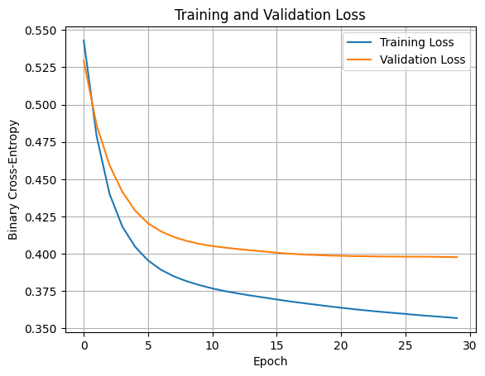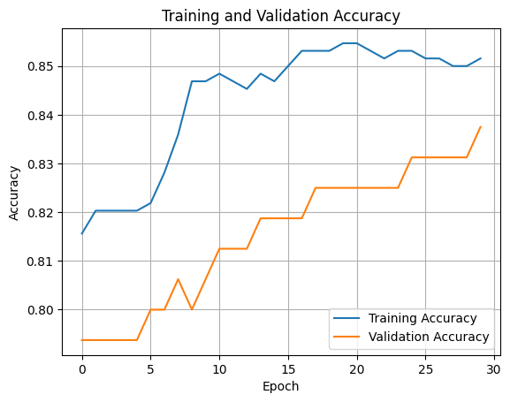

Accuracy: 0.81
Precision: 0.8492
Recall: 0.9325
F1 Score: 0.8889
Confusion Matrix:
[[ 10 27]
[ 11 152]]
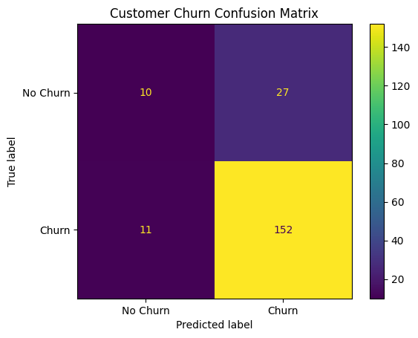
Width: 8 Test Loss: 0.4695 Test Accuracy: 0.815
Width: 16 Test Loss: 0.454 Test Accuracy: 0.82
Width: 32 Test Loss: 0.4455 Test Accuracy: 0.8
Width: 64 Test Loss: 0.4565 Test Accuracy: 0.8
Result:
The Multilayer Perceptron was trained and evaluated successfully, and its classification performance was analysed.
Experiment 10: L2 Regularization, Dropout and Early Stopping
Aim:
To apply L2 regularization, dropout, and early stopping to a neural network and analyse how these techniques help reduce overfitting.
Algorithm:
- Prepare the training and validation datasets.
- Build a neural network without regularization.
- Train the model and record training and validation losses.
- Apply L2 regularization, dropout, and early stopping.
- Train the modified models.
- Compare their training and validation performance.
- Identify the techniques that improve generalization.

Code:
#10) L2, Dropout and Early Stopping Comparison

import numpy as np
import pandas as pd
import matplotlib.pyplot as plt
import tensorflow as tf
from sklearn.datasets import make_classification
from sklearn.model_selection import train_test_split
from sklearn.preprocessing import StandardScaler
np.random.seed(42)
tf.random.set_seed(42)
# Generate 500 illustrative clinical records
X, y = make_classification(
n_samples=500, n_features=10, n_informative=6,
n_redundant=2, class_sep=0.8, flip_y=0.05,
random_state=42
)
X_train, X_test, y_train, y_test = train_test_split(
X, y, test_size=0.2, random_state=42, stratify=y
)
scaler = StandardScaler()
X_train = scaler.fit_transform(X_train)
X_test = scaler.transform(X_test)
X_fit, X_val, y_fit, y_val = train_test_split(
X_train, y_train, test_size=0.2, random_state=42,
stratify=y_train
)
def build_model(l2=0, dropout=0):
reg = tf.keras.regularizers.l2(l2) if l2 else None
layers = [
tf.keras.layers.Input(shape=(X_train.shape[1],)),
tf.keras.layers.Dense(256, activation="relu",
kernel_regularizer=reg),
tf.keras.layers.Dense(256, activation="relu",
kernel_regularizer=reg)
]
if dropout:
layers.append(tf.keras.layers.Dropout(dropout))
layers.extend([
tf.keras.layers.Dense(128, activation="relu",
kernel_regularizer=reg),
tf.keras.layers.Dense(1, activation="sigmoid")
])
model = tf.keras.Sequential(layers)
model.compile(
optimizer="adam",
loss="binary_crossentropy",
metrics=["accuracy"]
)
return model
results = []
histories = {}
def evaluate_model(name, model, history):
train_acc = model.evaluate(X_fit, y_fit, verbose=0)[1]
test_acc = model.evaluate(X_test, y_test, verbose=0)[1]
results.append({
"Model": name,
"Train Accuracy": train_acc,
"Test Accuracy": test_acc,
"Train-Test Gap": train_acc - test_acc
})
histories[name] = history.history
# Task 1: Large baseline MLP
tf.keras.utils.set_random_seed(42)
model = build_model()
history = model.fit(
X_fit, y_fit, validation_data=(X_val, y_val),
epochs=100, batch_size=16, verbose=0
)
evaluate_model("Baseline", model, history)
# Task 2: L2 regularisation at three lambda values
for lam in [0.0001, 0.001, 0.01]:
tf.keras.utils.set_random_seed(42)
model = build_model(l2=lam)
history = model.fit(
X_fit, y_fit, validation_data=(X_val, y_val),
epochs=100, batch_size=16, verbose=0
)
evaluate_model("L2=" + str(lam), model, history)
# Task 3: Dropout at three rates
for rate in [0.2, 0.3, 0.5]:
tf.keras.utils.set_random_seed(42)
model = build_model(dropout=rate)
history = model.fit(
X_fit, y_fit, validation_data=(X_val, y_val),
epochs=100, batch_size=16, verbose=0
)
evaluate_model("Dropout=" + str(rate), model, history)
# Task 4: Early stopping
tf.keras.utils.set_random_seed(42)
model = build_model()
early_stop = tf.keras.callbacks.EarlyStopping(
monitor="val_loss", patience=8, restore_best_weights=True
)
history = model.fit(
X_fit, y_fit, validation_data=(X_val, y_val),
epochs=100, batch_size=16, callbacks=[early_stop], verbose=0
)
evaluate_model("Early Stopping", model, history)
print(pd.DataFrame(results).round(4).to_string(index=False))
# Plot baseline and regularised validation losses
plt.figure(figsize=(9, 5))
for name in ["Baseline", "L2=0.001", "Dropout=0.3", "Early Stopping"]:
plt.plot(histories[name]["val_loss"], label=name)
plt.xlabel("Epoch")
plt.ylabel("Validation Loss")
plt.title("Overfitting Prevention Comparison")
plt.legend()
plt.grid()
plt.show()
Output:
Model Train Accuracy Test Accuracy Train-Test Gap
Baseline 1.000 0.81 0.190
L2=0.0001 1.000 0.82 0.180
L2=0.001 1.000 0.82 0.180
L2=0.01 1.000 0.82 0.180
Dropout=0.2 1.000 0.82 0.180
Dropout=0.3 1.000 0.79 0.210
Dropout=0.5 1.000 0.80 0.200
Early Stopping 0.975 0.85 0.125
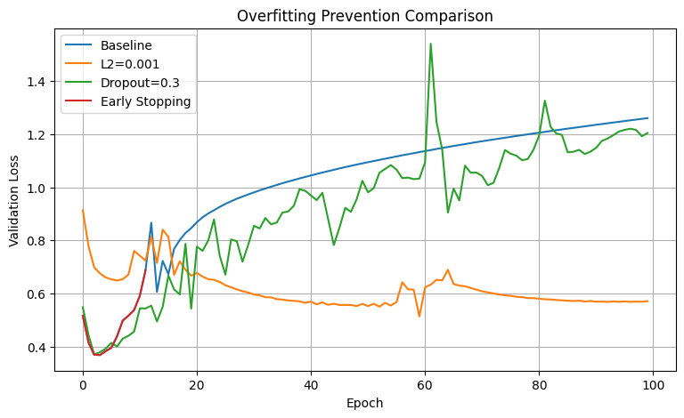
Result:
L2 regularization, dropout, and early stopping were implemented and compared to understand their effects on overfitting and generalization.

